Good Housekeeping Practices and Pollution Prevention for Municipal Operations

A Guide for Stormwater Permittees
Rev. February 2020

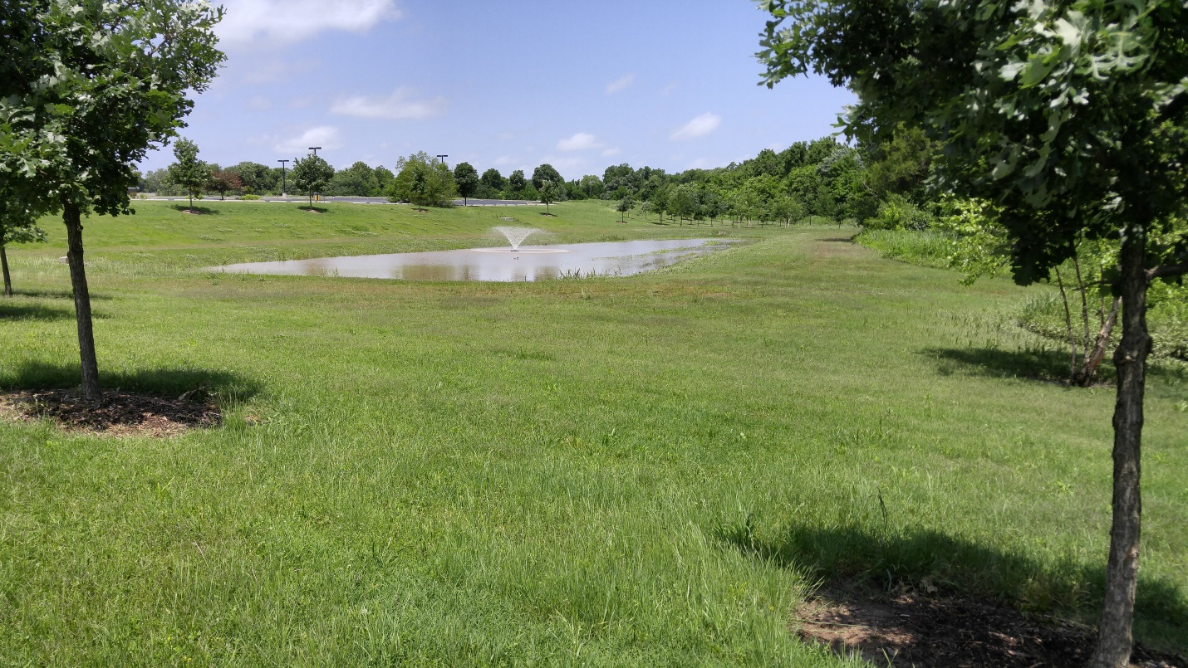

INCOG
2 West Second Street
Suite 800
Tulsa, OK 74103

This document was developed under a FY-16 EPA grant. Upon EPA approval, GCSA notations were added for distribution to INCOG’s GCSA Members.

Table of Contents
Section | Page
Section 1 Background | 3
1.1 Introduction | 3
1.2 Oklahoma OKR04 Phase II Requirements | 3
1.3 Stormwater Pollutants | 5
Section 2 Stormwater Plan for Municipal Operations | 6
2.1 Identify Municipal Facilities and Operations | 6
2.2 Identify BMPs and GHPs | 7
2.3 Implement BMPs and GHPs | 7
2.4 BMP Effectiveness | 8
Section 3 BMP Options | 8
3.1 Education and Outreach | 8
3.2 Non-Stormwater Discharges | 9
3.3 Reduce the Use of or Switch to Less Hazardous Materials | 10
3.4 Spill Response and Prevention Plan | 10
3.5 Fueling Operations | 11
3.6 Vehicle Maintenance Facilities | 11
3.7 Hazardous Materials and Outdoor Container Storage | 12
3.8 Material Management and Storage | 12
3.9 Parks and Open Spaces | 13
3.10 Roadways and Parking Lots | 14
3.11 Fountains and Swimming Pools | 14
3.12 Stormwater Collection System Maintenance | 15
3.13 Waste Handling and Disposal | 15
3.14 Pet Waste Handling | 16

Acronym Table
BMP | Best Management Practice
GHP | Good Housekeeping Practice
LID | Low Impact Development
MEP | Maximum Extent Practicable
MS4 | Municipal Separate Storm Sewer System
SDS | Safety Data Sheets

Section 1 Background
1.1 Introduction
Stormwater runoff naturally occurs after precipitation events or snow melt. Land development and agricultural practices can alter natural drainage patterns and increase runoff volumes. In addition, land use and various activities can contribute pollutants to the runoff which eventually reaches our streams, rivers, lakes and ponds. This is often more pronounced in urban runoff, which includes flows from urban areas into stormwater conveyance systems and receiving waters. Wet weather runoff and dry weather runoff (irrigation sprinklers, line flushing, swimming pool cleanouts, etc.) can contribute to surface water pollution which has a negative impact on fisheries, water recreation, water supply sources and property values. Collectively these pollutants reduce the aesthetics and livability of a community.
For many years, flood control was the primary runoff concern. A reduction in immediate runoff volume was the goal. Now, in addition to volume control the nation is concerned about water quality. As a result, we have federal, state and municipal programs aimed at reducing pollution in stormwater runoff. Many cities and counties have a Phase I or II stormwater permit that requires the municipality or county to implement best management practices (BMPs) and follow good housekeeping practices (GHPs) at municipal facilities. Municipal facilities can include parks and open spaces, fleet and building maintenance facilities with outdoor storage areas, sand and salt storage areas, waste transfer stations, streets, roads, highways, parking lots, snow disposal areas, airports, fire stations, police stations, etc.
The purpose of this manual is to provide assistance to municipalities in training and educating employees and the general public and help them better understand what GHPs and BMPs they can implement to reduce stormwater pollution. It isn’t possible to discuss all of the aspects regarding pollution control in this manual or list all possible BMPs or GHPs, but it will aid the reader in understanding the major points and principles that will assist in reducing pollutant runoff to the maximum extent practicable (MEP) from municipal sites.
The conditions and activities occurring at each facility will dictate which BMPs and GHPs are most appropriate. Consider this a starting point and add BMPs that best fit your needs. A few examples are given in each table following a brief discussion of why protective measures are needed. Add additional BMPs to each table to custom fit this document and make it a living document by adjusting it as conditions change at your facilities.

1.2 Oklahoma OKR04 Phase II Requirements
The November 1, 2015 OKR04 Phase II Small Municipal General Stormwater Permit for Oklahoma stipulates the following in the Sixth Minimum Control Measure regarding Pollution Prevention and Good Housekeeping.

6. Pollution Prevention/Good Housekeeping For MS4 Operations
a. Permit Requirements
You must review and revise your existing pollution prevention and good housekeeping program, as necessary. The revision shall be completed within the first year after the effective date of this Permit, then as needed. You must develop new elements, as necessary, and continue to implement and enforce the operation and maintenance program that includes a training component and has the ultimate goal of preventing or reducing pollutant runoff from MS4 operations. You must:
(1) Use training materials that you develop or that are available from EPA, DEQ, or other reputable organizations. Your pollution prevention and good housekeeping program must include employee training to prevent and reduce stormwater pollution from activities such as park and open space maintenance, fleet and building maintenance, new construction and land disturbances, and stormwater system maintenance;
(2) Implement a municipal employee training and education program that you will use to prevent and reduce stormwater pollution from MS4 activities. Describe any existing, available materials you plan to use. Describe how this training program will be coordinated with the outreach programs developed for the public information minimum measure and the illicit discharge MCM;
(3) Maintain a list of industrial facilities you own or operate that are subject to the DEQ Multi-Sector General Permit or individual OPDES or NPDES permits for discharges of stormwater associated with industrial activity that ultimately discharge to your small MS4. Include the authorization number or a copy of the Industrial NOI form for each facility. You must review this inventory annually and update as necessary;
(4) Implement procedures for controlling, reducing or eliminating the discharge of pollutants from streets, roads, highways, parking lots, maintenance and storage yards, waste transfer stations, fleet or maintenance shops with outdoor storage areas, and salt/sand storage locations and snow disposal areas you operate;
(5) Implement procedures to ensure that new flood management projects are assessed for impacts on water quality;
(6) Implement inspection/maintenance for structural and non-structural BMPs, including maintenance activities, maintenance schedules and long term inspection procedures for controls to reduce floatables and other pollutants discharged to your small MS4;
(7) List and define the BMPs that you or another entity will implement in the pollution prevention and good housekeeping program. You must include, as appropriate, the months and years in which you will undertake required actions, including interim milestones and the frequency of the action. Also you must identify who will be responsible for implementing or coordinating the BMPs in this program;
(8) Establish or revise (as necessary) measurable goals for each BMP, including target milestones (month and year), frequency of action(s) and identify responsible persons; and
(9) Evaluate the appropriateness of your identified BMPs for this MCM. Your evaluation shall verify compliance with permit requirements and more importantly, document that efforts have been made towards achieving your identified measurable goals and reducing the impacts of stormwater runoff from the small MS4 (as required by Part V.C of this Permit).
b. Recommendations
(1) Develop an inventory of all your MS4 operations that are impacted by this program. Review this inventory annually and update as necessary.
(2) Establish procedures for proper use, storage, and disposal of both petroleum and non-petroleum products at schools, town offices, police and fire stations, pools, parking garages and other permittee-owned or operated buildings or utilities. Develop or continue to implement a Spill Response and Prevention Plan to ensure that appropriate actions will take place when a spill occurs within your small MS4.
(3) Establish procedures for the proper storage of permittee-owned vehicles and equipment, including fueling areas. Ensure that vehicle wash waters are not discharged to the small MS4.
(4) Establish procedures for catch basin inspections, cleaning and repairs, and sweeping streets, sidewalks, and permittee-owned parking lots within your small MS4.

Basically it contains three components.
- You must have an operations and maintenance program intended to prevent or reduce stormwater runoff;
- Have a training program for municipal personnel; and
- Implement BMPs with measurable goals, document them and track their effectiveness.

1.3 Stormwater Pollutants
Some of the pollutants associated with stormwater are: sediment (soil, sand), heavy metals (copper, lead, chromium, nickel, zinc, mercury, aluminum, etc.), organics (solvents, paint residue, asphalt components) agricultural and turf chemicals (pesticides, herbicides), nutrients (nitrogen, phosphorus, potassium), road salts and deicers, chlorine (swimming pools, water leaks), oil and grease, fuels, automotive fluids, bacteria and viruses (animal excrement), and trash and litter.
The presence of these pollutants can negatively impact the use of surface and groundwater in many ways. Polluted drinking water sources are more costly to treat and may even become unacceptable or too expensive to use. Polluted surface water can become aesthetically unappealing or provide unnecessary risks to citizens and limit recreational activities. Pollutants can also limit the biological communities that live in, on and around waters and result in fish kills. Trash, litter and debris can block drainage pipes, plug pumps and increase flooding dangers. In general pollution limits the use of or increases the cost of using or enjoying a resource that is valued in different ways by everybody.

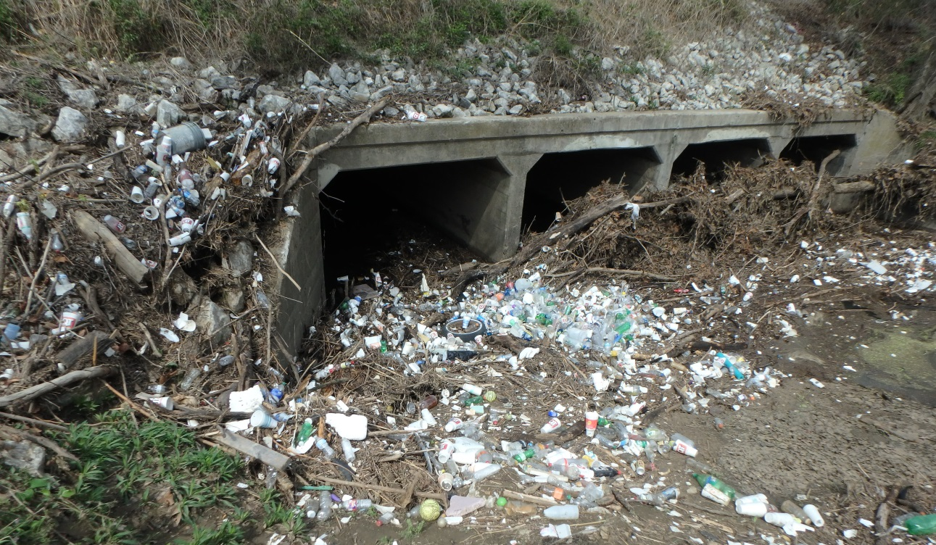
Section 2 Stormwater Plan for Municipal Operations
2.1 Identify Municipal Facilities and Operations
The first step is to identify and list all municipal facilities and operations that could potentially contribute to stormwater runoff pollution and the history of any spills and releases. This would include physical structures and buildings and also parks, open spaces, roads, highways, parking lots, storage lots or any municipally owned ground where activities are conducted that could release a pollutant to a surface exposed to precipitation or runoff. A few examples are listed in Table 2.1, Potential Municipal Pollutant Sources.

Table 2.1 Potential Municipal Pollutant Sources
Facility | Potential Pollutant Source
Municipal Waste, Disposal and Recycling Facilities | Municipal Landfills (Active or Closed)
Municipal Waste, Disposal and Recycling Facilities | Publicly Owned Treatment Facilities
Municipal Waste, Disposal and Recycling Facilities | Incinerators and Refuse Staging Areas
Municipal Waste, Disposal and Recycling Facilities | Land Application Sites
Municipal Waste, Disposal and Recycling Facilities | Recycling Centers
Municipal Waste, Disposal and Recycling Facilities | Waste Transfer Stations
Maintenance and Storage Areas | Vehicle Storage Yards
Maintenance and Storage Areas | Vehicle Maintenance and Fueling Facilities
Maintenance and Storage Areas | Salt and Sand Storage Facilities
Maintenance and Storage Areas | Material Storage Facilities
Maintenance and Storage Areas | Snow Removal Storage Areas
Other Municipal Sites | Municipal Airports
Other Municipal Sites | Parks, Golf Courses and Cemeteries
Other Municipal Sites | Public Buildings (Police, Fire, Libraries, Courthouse)
Other Municipal Sites | Municipal Swimming Pools and Splash Pads
Other Municipal Sites | Animal Shelters and Associated Areas
Other Municipal Sites | Roadways and Parking Lots
Other Municipal Sites | Fairgrounds
Other Municipal Sites | Water Treatment Plants
Other Municipal Sites | Vehicle Washing Facilities

If your municipality or county has additional facilities or activities, add them to the list. Next evaluate the activities at each of these locations along with the chemicals and materials used and stored. List the chemicals and materials and the likelihood that they could be picked up by runoff. If all of the operations at a site are performed indoors or under the cover of a roof and runoff doesn’t flow across the work areas, there would be practically no stormwater pollution risk during normal operations. For more information, refer to the appropriate Spill Response and Prevention Plan.
Then consider what chemicals or materials are used or stored at that facility and how they get there or their manner of disposal. If the facility has a shipping dock that is under a roof and runoff doesn’t flow across it, loading and unloading activities are probably secure. If loading and unloading facilities are not covered and protected, than a spill during these operations could result in stormwater pollution.
If chemicals and materials are piped in or hauled in and then unloaded (fuel tankers to onsite storage tanks) consider the ramifications of a faulty valve, hose break or a simple leak. If there is adequate containment and protection from the elements, risk could be minimal. If not, then BMPs and GHPs might be needed. Finally, think about how waste products will leave the facility. If there is a decent chance that a spill or accident could result in stormwater contamination during disposal activities, BMPs or GHPs might be needed.

2.2 Identify BMPs and GHPs
Once potential sources of pollution have been identified, and risk assessment has identified those with reasonable potential to contribute pollutants, it is time to determine which BMPs and GHPs should be implemented and where they would be most effective. Also, identify BMPs that are already in place. If pavements are being swept on a regular basis, drip pans are being used under leaks, waste bins are covered and chemical storage areas are being inspected at regular intervals, then some BMPs are already in place. If what is in place effectively deals with the potential pollution source maybe adequate measures are in place to minimize or eliminate the hazard.
For stormwater, best management practices (BMPs) are control measures put in place to mitigate the negative changes in stormwater runoff quantity and quality caused by land use changes or activities. These BMPs can then be separated into “structural” and “non-structural”. Structural BMPs generally require the installation of something physical or altering the landscape. Non-structural BMPs are generally a practice or change in the way something is performed. Educating others in the use of low impact development (LID) practices is non-structural, but installing a rain barrel or rain garden would be a structural BMP.
Good housekeeping practices fit into the non-structural category. They include cleaning parking lots, inspecting dumpsters and storage areas, material storage policies, training and education and requirements to conduct maintenance on vehicles and equipment. From this point on, GHPs will be considered as BMPs. Specific practices may be referred to as GHPs when the intent is to differentiate them from BMPs in specific situations.
Work on source control BMPs first. It is generally easier and less expensive to prevent or minimize a spill than it is to clean one up so implement source control measures before treatment BMPs. Treatment BMPs deal with the spill after the fact. They involve methods designed to contain and recover a pollutant. If that fails, the next step is to treat potentially large quantities of polluted water at considerably greater expense. This document is not intended to cover the numerous aspects involved in cleaning up a polluted waterway, so the majority of the listed BMPs are source control measures.

2.3 Implement BMPs and GHPs
After municipally owned land and facilities have been identified, potential pollutant sources have been identified and BMPs and GHPs have been selected, it is time to implement the BMPs and GHPs. Select the locations where structural BMPs would be most beneficial. Consider maintenance costs and ease of access as well as installation costs.
Non-structural BMPs and GHPs need to be written and documented. Your documentation should include how often to conduct an inspection, perform maintenance, review a policy, who should be responsible for the task and where and how the records regarding this work will be kept.
2.4 BMP Effectiveness
The final step here is to evaluate the effectiveness of your BMPs. Your BMPs should be capable of preventing a spill or release and/or capable of containing any releases before they can be carried off-site by runoff. Inspection and accident incident reports will help document your successes and failures. Sampling and analytical work can also be used to show that pollutant loadings are decreasing in stormwater runoff and nearby streams.

Section 3 BMP Options
3.1 Employee Training, Education and Outreach
A strong education and outreach program is a cost effective way to reduce pollutant loads throughout your municipality. Educate citizens on litter reduction, lawn care product applications, vehicle maintenance and the cleaning of swimming pools. Educate industries on chemical controls and discharges, grounds keeping practices, waste storage and parking lot maintenance. Educate construction sites on erosion control, litter control and chemical and fuel storage. Educate municipal employees on all of the above and more.
Education and outreach is primarily a source control BMP aimed at preventing pollution. Training should be an ongoing activity, not a onetime event. New employees and employees undertaking new tasks should be thoroughly trained before they begin new assignments and all employees need refresher updates and additional training whenever circumstances warrant.
Fairs and festivals provide good opportunities to set up a booth, hand out brochures, and talk to the general public about stormwater and pollution. Visit schools and talk to children and young adults about pollution prevention. They are the future leaders and helping them understand the importance of sustainable practices, what pollution costs society and how they can make a difference will make the job easier in the future. Set up brochure racks with information regarding stormwater and pollution prevention in public places to make the information easy for people to get. Use social media, websites, newspaper articles, and add campaigns through TV and radio spots to help get the message out.
Education and outreach programs are almost always source control and non-structural BMPs which makes them relatively inexpensive to implement. The goal is to educate others so spills and illicit discharges don’t occur as often and therefore cleanup costs are avoided. Education is an important component of most BMPs so even though it won’t be mentioned after each of the following BMPs, it is understood to apply.

Table 3.1 Education and Outreach BMPs
BMP | Source Control | Treatment | Non-Structural | Structural
Booths at fairs and festivals | X |  | X
Presentations at schools | X |  | X
Brochure racks in public places | X |  | X
Social media, websites, newspaper articles, and add campaigns | X |  | X
Conduct employee training on pollution prevention | X |  | X
3.2 Non-Stormwater Discharges
Non-stormwater discharges are flows that are not entirely comprised of stormwater. This could include stormwater mixed with other solids or liquids or liquids other than rain or snow melt runoff. Some flows from exempted activities are permissible under the Phase II OKR04 permit and not considered illicit discharges. Review your permit to see what can and can’t be discharged as stormwater. Your dry weather field screening activities are intended to help you identify illicit discharges and source tracking is how you locate the source of the pollutant. Educate all municipal employees so they will be able to recognize an illicit discharge and make sure they know who to call to report suspicious activities. They are out in the field a good deal of the time and can help by expanding your program’s reach.
Posting “No Dumping” signs is source control because the intent is to prevent the discharge of a pollutant before it enters the environment. The sign should include contact information and mention of a fine for violations. This is also a treatment BMP because identification and notification of a spill or release is the first step in the cleanup process. Label storm drains so citizens will know that anything going down that drain goes directly to a stream, river, pond or lake without treatment. Post “No Dumping” signs with contact information for reporting illegal dumping at illegal roadside dumps. These are frequently in drainage ditches that drain directly to surface waters. To further discourage these activities, lighting and surveillance cameras may help and will make enforcement activities easier.
Monitoring for dry weather flows and using cameras to scope stormwater pipes will help locate illicit residential and industry taps into the stormwater collection system. When illegal taps are found, responsible parties should be notified and the tap promptly disconnected. Smoke or dye testing is another way to identify or verify a suspected illegal tap.
To make recycling and disposal of hazardous materials easier for the community, municipalities can provide recycling centers and household hazardous waste collection facilities or events. Recycling used automotive fluids, plastics, paper, glass, paints, lawn care products, aluminum, etc. reduces the volume that might have ended up in a surface water or landfill.

Table 3.2 Non-Stormwater Discharges
BMP | Source Control | Treatment | Non-Structural | Structural
Dry weather field screening activities | X |  | X
Source tracking | X |  | X
Stop illicit discharges identified through dry weather field screening and source tracking |  | X | X | X
Post “No Dumping” signs with contact information for reporting | X | X |  | X
Label storm drain inlets | X |  |  | X
Post “No Dumping” signs at illegal roadside dumps | X | X |  | X
Use dry weather flows and cameras to identify illegal stormwater taps | X | X | X
Smoke or dye test suspected illegal taps | X | X | X
Disconnect illegal taps to the stormwater collection system |  | X |  | X
Recycling and household hazardous waste collection | X |  |  | X

3.3 Reduce the Use of or Switch to Less Hazardous Materials
Review the chemical and material lists for each municipal site and identify chemicals, products and materials that are potential pollutants. Then research alternatives that are less toxic and less likely to be problematic. If there are no good alternatives, maybe it is possible to use less of these products. By using less, it means the products won’t be handled as frequently, shipped as often, stored in greater volumes and may result in lower disposal costs. All of this reduces the risk of a spill or accidental release. A review of cleaners, deicing agents and lawn care products would be a good place to start.

Table 3.3 Reduce the Use of or Switch to Less Hazardous Materials
BMP | Source Control | Treatment | Non-Structural | Structural
Decrease the use of hazardous or toxic materials | X |  | X
Switch to less hazardous and toxic materials | X |  | X

3.4 Spill Response and Prevention Plan
Spill response and prevention activities are one of the most important GHP municipalities can implement. Municipal employees use, transport and dispose of materials every day that could become pollutants if mishandled. A spill response and prevention plan provides guidelines, establishes authority and responsibility and makes work environments healthier, safer and more environmentally friendly.
Prepare a Spill Response and Prevention Plan specific for each of your municipal facilities. Preparing a plan is an exercise that will identify potential pollution sources, measures that are currently in place to minimize the hazard and define how a cleanup will occur. You can build upon this by adding measures (BMPs) to address weaknesses identified in the process to decrease the likelihood that a pollutant will be carried offsite by stormwater runoff. The plan should address how employees will use, handle, store, load, and dispose of chemicals and materials that could pose a pollution risk and how a response team will handle a spill or release.
To help prevent spills, maintain clear and adequate isle space in storage areas, when handling products outside, work over impervious surfaces and cover or berm storm drains near work areas, use secondary containment or berms when storing or transferring products, and install leak detection devices where liquids are stored. Frequently inspect liquid storage containers for signs of rust, damage and leaks. Finally, have cleanup equipment such as barrels, shovels, absorbents and safety and personal protection gear near storage and work areas at all times. Train all personnel in the proper response if a spill or accidental release occurs. For details, refer to the Spill Response and Prevention Plan.

Table 3.4 Spill Response and Prevention Plan
BMP | Source Control | Treatment | Non-Structural | Structural
Prepare a Spill Response and Prevention Plan | X | X | X | X
Train employees in prevention and spill response measures | X |  | X

3.5 Fueling Operations
Fueling vehicles and equipment can result in stormwater pollution if fuels are spilled and not contained and cleaned up. Spills can occur during transfer from transport vehicles to onsite storage tanks and then from the storage tank to vehicles. Discourage the practice of topping off tanks. Store cleanup equipment and materials close to fueling stations with the location plainly marked by signage. Install overflow detection or cutoff devices on tanks to minimize spills during filling.
Surfaces in fueling areas should be impervious, able to contain any spills and bermed to make cleanup easier. Installing a roof over the fueling area to protect it from precipitation will also minimize contact between runoff and fuels. Install barriers around tanks to protect them from vehicle damage. Label all valves and pipes to help reduce human error.

Table 3.5 Fueling Operations
BMP | Source Control | Treatment | Non-Structural | Structural
Install overflow detection and cutoff devices | X |  |  | X
Install impervious and bermed surfaces around fueling areas |  | X |  | X
Protect the fueling area from precipitation | X |  |  | X
Install protective barriers around tanks | X |  |  | X
Label valves and pipes | X |  | X

3.6 Vehicle Maintenance Facilities
Vehicle fluids spilled or leaked at maintenance facilities can contribute to stormwater pollution. To minimize this, do all repairs indoors or in a covered area not exposed to precipitation whenever possible. If vehicles and equipment with fluid leaks must be parked outdoors, place drip pans under them to collect any leaking fluid.
Store bulk vehicle fluids, both new and used, indoors or under the protection of a roof and in a manner so that all leaks will be contained. Properly dispose of all vehicle waste fluids. Recycling is the best option when possible. Train all employees in the safe and proper way to handle wastes.
Vehicle wash water contains detergents along with oil, grease, heavy metals, suspended solids and whatever has splashed up from road surfaces. All of these substances contribute to the pollutant load entering our surface waters if not disposed of properly. Wash vehicles in wash bays that drain first to an oil/grease trap and then to the sanitary sewer and place a trash container in each wash bay. If this is not possible, wash vehicles at a location where the wash water flows over and through a vegetated area and allows enough time for the water to soak into the soil. This allows vegetation, soil and microbes in the soil to break down and assimilate pollutants before they reach a receiving stream or aquifer.
If possible, dry clean parts only. If solvents are necessary, select less toxic alternatives if they are available and don’t use more than necessary. Properly dispose of all spent solvents.

Table 3.6 Vehicle Maintenance Facilities
BMP | Source Control | Treatment | Non-Structural | Structural
Perform vehicle repairs indoors | X |  |  | X
Use drip pans | X |  | X
Vehicle fluids are protected from the elements | X |  |  | X
Vehicle wash water does not drain directly to a surface water | X |  |  | X

3.7 Hazardous Materials and Outdoor Container Storage
Hazardous materials pose a pollution risk when not handled properly and should be safely stored, under cover, and with restricted access. For safety reasons, placards should properly identify the types or characteristics of hazardous materials present and be placed in conspicuous locations near entries. Provide secondary containment for all hazardous material containers to minimize risk. The containment area should be slightly larger than the largest container. If containers must be stored outdoors, try to provide overhead cover and regulate run-on and runoff.

Table 3.7 Hazardous Materials Storage
BMP | Source Control | Treatment | Non-Structural | Structural
Hazardous Materials are stored protected from precipitation | X |  |  | X
Secondary containment is used | X |  |  | X
Provide cover for outdoor container storage areas | X |  |  | X

3.8 Material Management and Storage
Material management is the complete process beginning with deciding what to purchase, purchasing, storage, handling, use and ultimately the disposal of these materials. Good inventory records will allow you to determine how much material you have in stock, what you are using most and might allow you to determine which products you no longer need to purchase or keep in stock. When handling materials, don’t overload pallets or use broken pallets. This greatly increases the likelihood of a spill. Dumpsters and trash receptacles should have covers that prevent the entry of rain and snow and not have holes in the bottom that allow fluids to leak out.
Sand, salt, deicing materials, compost, mulch and wood products treated with anti-decay agents (landscape timbers, railroad ties, etc.) should be stored in a manner that protects the materials from precipitation and stormwater runoff. Any product that could contaminate stormwater should be protected from the elements, stored in their original container (whenever possible) and properly labeled. If product such as this must be stored in temporary piles and exposed to the elements, cover the pile with plastic sheeting that is well secured around the edges. This not only protects it from rain and runoff, but also minimizes wind distribution. Wind can pick up and carry pollutants off site. Safety data sheets (SDS) should be kept in conspicuous areas and all employees should be trained in how to read one. The information regarding safe handling and proper cleanup of spills can reduce the inherent risk of using these materials and expedite cleanup operations if a spill does occur.

Table 3.8 Material Management and Storage
BMP | Source Control | Treatment | Non-Structural | Structural
Dumpsters and trash receptacles have covers and no leaks | X |  |  | X
Sand, salt and deicing materials protected from the elements | X |  |  | X

3.9 Parks and Open Spaces
Parks and open spaces can contribute pollutants through routine landscaping practices. Pollutant loads can be reduced by not applying fertilizers, insecticides and weed killers unnecessarily and switch to nontoxic products if possible. If only portions of an area need treating, spot treat and don’t broadcast the whole area. Test the soil before applying fertilizer to determine need. If automatic sprinklers are used, install rain or moisture sensors to minimize runoff and check irrigation schedules before applying lawn care products. To reduce the need for irrigation and fertilize applications, plant native vegetation that is adapted to local conditions. These species will need less care and be less expensive to maintain.
To keep lawn care products out of waterways, maintain a chemical free buffer around shorelines. If a mosquito abatement program uses foggers, do not fog over, adjacent to or, on windy days, upwind of surface waters.
Time herbicide and insecticide applications to maximize benefit and minimize use. Insects and plants are usually more sensitive to these compounds when they are in early development stages and actively growing. Correct timing will reduce the amount of chemical needed and the need to reapply as often. When mowing, mulch grass instead of bagging, chip wood to make mulch to cover bare ground and compost other forms of vegetation. Lawn clippings contain nutrients and frequently pesticides and herbicides, so sweep or blow them off of paved areas so they won’t wash into waterways with the next rain event.
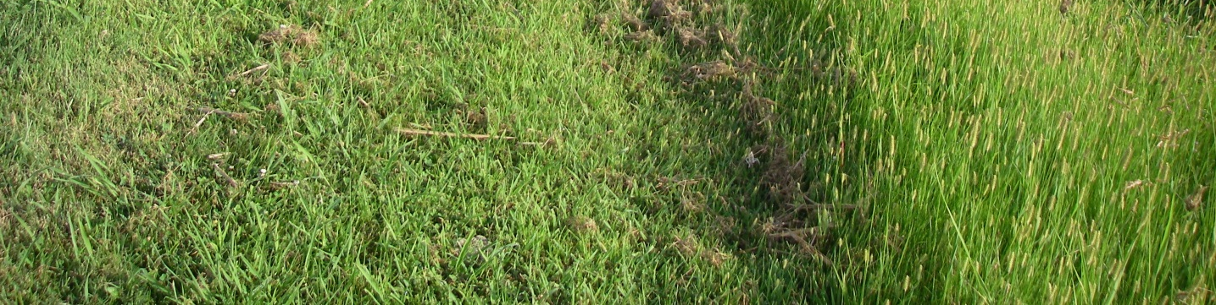

Table 3.9 Parks and Open Spaces
BMP | Source Control | Treatment | Non-Structural | Structural
Maintain chemical free buffers around waterways | X |  | X
Grass is mulched and bare soil is protected | X |  | X
Compost vegetation | X |  | X

3.10 Roadways and Parking Lots
Impervious roadways and parking lots collect pollutants like oils, chemicals, litter, heavy metals, bacteria and solids and then discharge them to surface waters during the next runoff event. Street sweeping and litter cleanup activities, especially after parades, street parties and other public events, help keep these pollutants out of the local waterways.
Road and parking lot maintenance activities have the potential to generate stormwater pollutants such as heavy metals, sediment, organics, and vehicle fluids. Patch asphalt, concrete and apply seal coats during dry weather and seal any storm drain inlets to prevent any pollutants from entering the stormwater collection system. Snow removal, sand applications and deicing operations are necessary to protect property and lives, but don’t over apply these materials. Have spreading equipment calibrated so over application is avoided and have equipment fitted with ground speed controllers or sensors so rate of application will vary with vehicle speed.
Sweep or vacuum dry material after painting, paint/stripe removal, saw cutting operations and other activities that generate dust and debris. Also, don’t apply paint or striping under windy or rainy conditions.

Table 3.10 Roadways and Parking Lots
BMP | Source Control | Treatment | Non-Structural | Structural
Use street sweepers and road cleaning crews | X |  |  | X
Sand, salt and deicing equipment is calibrated | X |  | X

3.11 Fountains and Swimming Pools
The primary concerns with fountains and swimming pools is the release of chemical algaecides and chlorinated water. Chlorine or chloramine is commonly used as a disinfectant which leaves a chlorine residual. This helps protect swimmers, but becomes a pollutant and is toxic to fish, invertebrates and other aquatic organisms if it reaches a natural surface water. Algaecides are added to fountains to inhibit algae growth for aesthetic reasons. When algaecides enter natural surface waters they can disrupt the food chain and are considered a pollutant.
Regular maintenance, cleaning, good circulation, filtration and chlorination will reduce the need for algaecides in fountains. Copper based algaecides are perhaps the most damaging, so if algaecides are needed, use an alternative if you can. Before discharging water from a chlorinated pool, either allow the chlorine to dissipate naturally or use a chlorine neutralizing compound. Once the water has been dechlorinated it can be used for landscape irrigation or discharged to a sanitary sewer.

Table 3.11 Fountains and Swimming Pools
BMP | Source Control | Treatment | Non-Structural | Structural
Dechlorinate pool and fountain water before discharging | X |  | X
Have a regular cleaning and maintenance program | X |  | X

3.12 Stormwater Collection System Maintenance
The stormwater collection system can receive runoff from large urban areas, numerous activities and densely populated areas. With the runoff comes a wide variety of pollutants. Regularly inspecting, cleaning and maintaining inlets, retention/detention ponds, and roadside ditches can decrease the pollutant loading to surface waters and reduce the flooding potential. Labeling storm drains and educating citizens so they know they should not dump pollutants down storm inlets is an effective BMP. Having and promoting a phone number that citizens can call if they see potentially illegal activities will increase the likelihood illicit activities will be identified.

Table 3.12 Stormwater Collection System Maintenance
BMP | Source Control | Treatment | Non-Structural | Structural
Regularly inspect the stormwater collection system | X |  | X
Regularly remove debris from the stormwater collection system |  | X | X
Have an inlet labeling program | X |  |  | X

3.13 Waste Handling and Disposal
Litter, trash and materials that no longer have value are handled and disposed of as waste. An active anti-litter campaign, good material management practices and a recycling program can reduce waste handling and disposal needs. This means less waste on site and easier management. Make sure trash receptacles are covered or protected from the elements and do not have leaks so everything placed in trash containers will stay in the container until proper disposal occurs.

Table 3.13 Waste Handling and Disposal
BMP | Source Control | Treatment | Non-Structural | Structural
Waste receptacles have lids and don’t leak | X |  |  | X
Recycle whenever possible | X |  | X

3.14 Pet Waste Handling
Pet waste from animal shelters and stray pet/animal containment areas must be carefully managed or high bacteria levels could be released to stormwater collection systems and ultimately to natural surface waters. Dog parks are also a potential source of bacterial pollution since they concentrate pet activities and exercise. Even public parks where citizens walk their dogs on leash can contribute to this bacteria loading. Provide pet waste stations that supply bags to pick up pet waste and receptacles to place this waste in. The more convenient these facilities are, the more likely they will be used.

Table 3.14 Pet Waste Handling
BMP | Source Control | Treatment | Non-Structural | Structural
Provide pet waste collection stations at dog parks and public parks | X |  |  | X
Animal shelters and pet/animal containment areas have an effective pet waste disposal program | X |  |  | X

